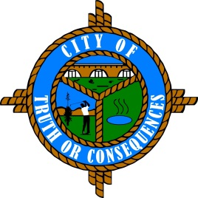
City of Truth or Consequences
405 W. Third
Truth or Consequences, New Mexico 87901
Phone: 575-894-6673 Fax: 575-894-7767

PUBLIC ARTS ADVISORY BOARD
REGULAR MEETING AGENDA
Tuesday, September 14, 2021 at 4:00 p.m.

ROLL CALL:
Sid Bryan, Tourism - Chairman
Cary “Jagger” Gustin, Sierra Arts Council – Vice-Chairman
Eduardo Alicea, Art Representative
Andy Underwood, Business Community

- APPROVAL OF THE AGENDA
- September 14, 2021

- APPROVAL OF MINUTES
- June 15, 2021 Meeting

- COMMENTS FROM THE PUBLIC
- NEW BUSINESS
- Discussion/Action: Geronimo Springs Fountain Improvements
- Discussion/Action: Recommendation for appointment of new board member. Applicant is Suzanne Carlstedt.

- REPORTS FROM THE BOARD
- REPORTS FROM STAFF
- SET TIME, PLACE AND DATE FOR NEXT MEETING
(Traditionally meets quarterly on the 3rd Tuesday of the month at 4:00 PM. However, regular meetings can be scheduled as needed.)

- ADJOURN

