City of Truth or Consequences
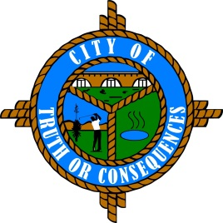
405 W. Third
Truth or Consequences, New Mexico 87901
Phone: 575-894-6673 Fax: 575-894-7767

PUBLIC ARTS ADVISORY BOARD
REGULAR MEETING AGENDA
Tuesday, January 10, 2023 at 4:00 p.m.

ROLL CALL:
Sid Bryan, Tourism - Chairman
Cary “Jagger” Gustin, Sierra Arts Council – Vice-Chairman
Eduardo Alicea, Art Representative
Andy Underwood, Business Community
Suzanne Carlstedt, Member

- APPROVAL OF THE AGENDA
- January 10, 2023

- APPROVAL OF MINUTES
- July 19, 2022 Meeting

- COMMENTS FROM THE PUBLIC
- NEW BUSINESS
- Discussion/Action: Well drilling estimates for City owned fountain on Main Street, Cary ‘Jagger’ Gustin
- Rainmaker Drilling Company
- Maverick Drilling Company

- REPORTS FROM THE BOARD
- REPORTS FROM STAFF
- SET TIME, PLACE AND DATE FOR NEXT MEETING
(Traditionally meets quarterly on the 3rd Tuesday of the month at 4:00 PM. However, regular meetings can be scheduled as needed.)

- ADJOURN

