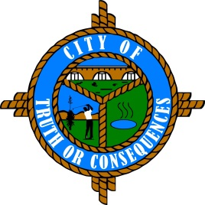
City of Truth or Consequences
405 W. Third
Truth or Consequences, New Mexico 87901
Phone: 575-894-6673 Fax: 575-894-7767

PUBLIC ARTS ADVISORY BOARD
REGULAR MEETING AGENDA
Tuesday, April 26, 2022 at 4:00 p.m.

ROLL CALL:
Sid Bryan, Tourism - Chairman
Cary “Jagger” Gustin, Sierra Arts Council – Vice-Chairman
Eduardo Alicea, Art Representative
Andy Underwood, Business Community
Suzanne Carlstedt, Member

- APPROVAL OF THE AGENDA
- April 26, 2022

- APPROVAL OF MINUTES
- September 14, 2021 Meeting

- COMMENTS FROM THE PUBLIC
- NEW BUSINESS
- Discussion/Action: Review 2 estimates for drilling at Geronimo Springs Fountain.
- Discussion/Action: Utilization of Lodgers Tax funds before the fiscal year ends.

- REPORTS FROM THE BOARD
- REPORTS FROM STAFF
- SET TIME, PLACE AND DATE FOR NEXT MEETING
(Traditionally meets quarterly on the 3rd Tuesday of the month at 4:00 PM. However, regular meetings can be scheduled as needed.)

- ADJOURN

