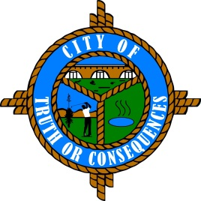
City of Truth or Consequences
405 W. Third
Truth or Consequences, New Mexico 87901
Phone: 575-894-6673 Fax: 575-894-7767

PUBLIC ARTS ADVISORY BOARD
REGULAR MEETING AGENDA
Tuesday, July 19, 2022 at 4:00 p.m.

ROLL CALL:
Sid Bryan, Tourism - Chairman
Cary “Jagger” Gustin, Sierra Arts Council – Vice-Chairman
Eduardo Alicea, Art Representative
Andy Underwood, Business Community
Suzanne Carlstedt, Member

- APPROVAL OF THE AGENDA
- July 19, 2022

- APPROVAL OF MINUTES
- April 26, 2022 Meeting

- COMMENTS FROM THE PUBLIC
- OLD BUSINESS
- Discussion/Update: Review of Shel Neymark work from June 1, 2022. Cary Gustin
- NEW BUSINESS
- Discussion/Update: Available Funds Review to date.
- Discussion/Action: Possible New Well for use in front of Geronimo Springs Museum.
- Discussion/Action: Re-contact Well Drillers for project.
- Discussion/Action: Ask Lodger’s Tax Advisory Board for additional funding for project.

- REPORTS FROM THE BOARD
- REPORTS FROM STAFF
- SET TIME, PLACE AND DATE FOR NEXT MEETING
(Traditionally meets quarterly on the 3rd Tuesday of the month at 4:00 PM. However, regular meetings can be scheduled as needed.)

- ADJOURN

