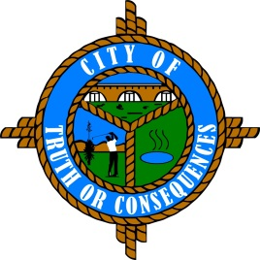
City of Truth or Consequences
405 W. Third
Truth or Consequences, New Mexico 87901
Phone: 575-894-6673 Fax: 575-894-7767

PUBLIC ARTS ADVISORY BOARD
REGULAR MEETING AGENDA
Tuesday, June 15, 2021 at 4:00 p.m.

ROLL CALL:
Sid Bryan, Tourism - Chairman
Eduardo Alicea, Art Representative
Cary “Jagger” Gustin, Sierra Arts Council
Andy Underwood, Business Community

- APPROVAL OF MINUTES
- July 21, 2020 Meeting

- COMMENTS FROM THE PUBLIC
- NEW BUSINESS
- Discussion/Action: Geronimo Springs Fountain Improvements
- Discussion/Action: Recommendation for re-appointment of Board Members Sid Bryan, Eduardo Alicea, Cary ‘Jagger’ Gustin, and Andy Underwood
- Discussion/Action: Reorganization of Chairman and Vice-Chairman

- REPORTS FROM THE BOARD
- REPORTS FROM STAFF
- SET TIME, PLACE AND DATE FOR NEXT MEETING
(Traditionally meets quarterly on the 3rd Tuesday of the month at 4:00 PM. However, regular meetings can be scheduled as needed.)

- ADJOURN
Please join my meeting from your computer, tablet or smartphone.
https://global.gotomeeting.com/join/145040669
You can also dial in using your phone.
United States: +1 (872) 240-3311 Access Code: 145-040-669
New to GoToMeeting? Get the app now and be ready when your first meeting starts: https://global.gotomeeting.com/install/145040669

